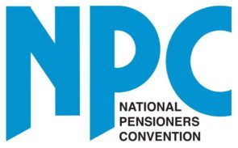

Ofcom consultation

quick, easy and reliable switching

Submission from the

National Pensioners Convention

April 2021

February 2016

Ofcom
Riverside House
2a Southwark Bridge Rd
London
SE1 9HA

14 April 2021

Dear Ofcom consultation team

NPC EVIDENCE FOR THE CONSULTATION
'quick, easy and reliable switching'

Introduction
The National Pensioners’ Convention (NPC) is Britain’s biggest independent organisation of older people, representing around one thousand local, regional, and national pensioner groups with a total of 1.5 million members. The NPC is run by and for pensioners and campaigns for improvements to the income, health and welfare of both today’s and tomorrow’s pensioners and this response is based on the views and experiences of our members.

We wish to submit views to the Ofcom for the consultation for the 'quick, easy and reliable switching' consultation. Our response has been compiled by our Digital Working Party as well as our Information Officer and will concentrate on the experiences and concerns of our members who are, by definition, in the older age range.

Consultation

The NPC does hold concerns in the way in which the consultation has been run. The only way to find out about and to respond to the consultation is via online methods. This will exclude millions of people from potentially giving their views on this important subject matter. The digital first approach must not be a digital only approach.

The NPC is campaigning for 'Connections For All', meaning that those who want go online and use the internet, computers and modern technology, should be given the access, help and training to do so to help digitally include them. However, we firmly believe that traditional forms of communication and services such as face to face, over the telephone and via post must remain in place. This is so as not to digitally excluded those who cannot use more modern technologies, those who do not wish to use them, and those who are priced out by equipment, broadband and upkeep costs, from our society.

We do support and appreciate the work of Ofcom in trying to balance the interests of service users and service providers, and we welcome Ofcom's promotion of healthy competition among service providers in order to achieve high levels of service for service users, as well as healthy competition between service providers. However, Ofcom's recent decision not to impose price caps on full-fibre connections as part of the copper switchover in 2025 will be see as prohibitive and exclusionary and may only further exacerbate the digital divide.

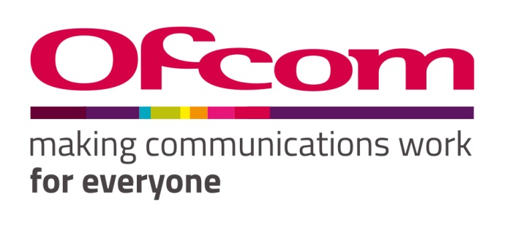
Consultation response form
Please complete this form in full and return to switching@ofcom.org.uk.

Consultation title | Quick, easy and reliable switching
Full name | Jonathan Safir (Information Officer)
Contact phone number | 0207-837-6622
Representing (delete as appropriate) | Organisation
Organisation name | National Pensioners Convention
Email address | info@npcuk.org

Confidentiality
We ask for your contact details along with your response so that we can engage with you on this consultation. For further information about how Ofcom handles your personal information and your corresponding rights, see Ofcom’s General Privacy Statement.
Your details: We will keep your contact number and email address confidential. Is there anything else you want to keep confidential? Delete as appropriate. | Whole response
Your response: Please indicate how much of your response you want to keep confidential. Delete as appropriate. | Whole response
For confidential responses, can Ofcom publish a reference to the contents of your response? | Yes

Your response
Question | Your response
Question 1: Do you agree with our proposal to require providers to develop and implement the One Touch Switch process? | Yes  The NPC welcomes Ofcom's concerns about assistive and supportive internet services for vulnerable and disabled users.  The current process does not cover customers switching between full-fibre broadband services or between networks. In these scenarios, customers need to coordinate the switch themselves, which can be confusing, unreliable and disjointed. Double paying for an overlap of service should end immediately.  With the proposed changeover from copper to fibre being scheduled for 2025, we will want to see it being made an absolute condition that all service providers will ensure that all service users will continue to receive an unbroken level of service during the transitional period of changeover and that there should be no increase in charges for those users who are reliant upon these services.  Improved customer choice and customers getting lower prices for improved services that better meet their needs ensuring they receive an unbroken service, should be the end result of the implementation of the One Touch Switch process.
Question 2: Do you agree with our proposal to remove the rules relating to the existing Notification of Transfer process? | Yes  Porting mobile numbers between suppliers should be simplified and made easier for consumers
Question 3: Do you agree with our proposed changes to require mobile providers to give residential customers information regarding the impact of a switch on any other services they have with the losing provider? | Yes  The NPC strongly believes that service users must be provided with the option to be able to talk to someone at their new and/or old service provider by telephone, and that that service should make it as easy as possible for the providers to get easy, quick and reliable access to technical support so as to rectify any faults or problems the service user may experience.  Signposting people to use messaging services or to use on-line web help pages is largely unhelpful and does not solve the problem for many service users - especially for older, disable and vulnerable users, when many of the help pages refer to jargon or use technical references.

Please complete this form in full and return to switching@ofcom.org.uk.

Should you require any further information, please use the contact information previously supplied.

Yours sincerely

Jonathan Safir
Information Officer

National Pensioners Convention
Marchmont Community Centre
62 Marchmont Street
London
WC1N 1AB

